How to fix PCIe error when using VPC-5600 with PER-T465 POE card under Ubuntu
Error screen:
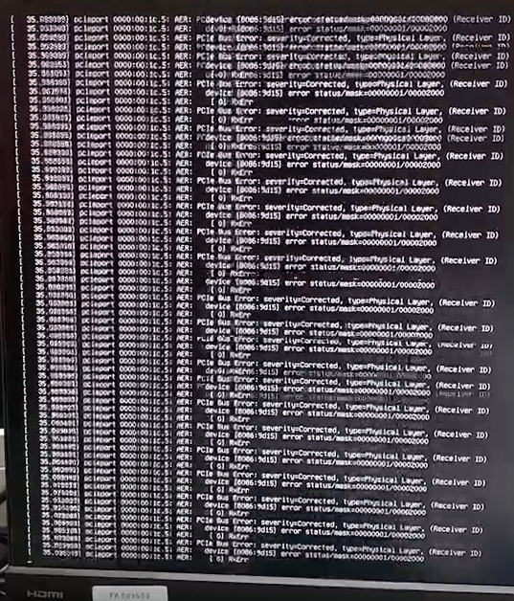

Step 1: Type Sudo gedit /etc/default/grub to add pcie_aspm=off as below photo.
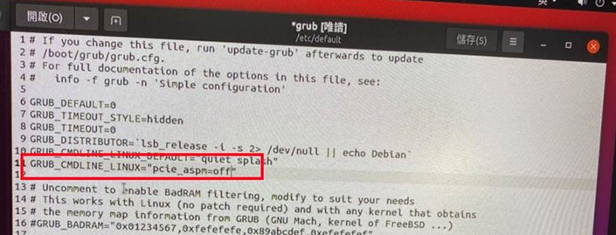

Step 2: Type sudo su to use root account. Type sudo grub-mkconfig -o /boot/grub/grub.cfg then the error could be fixed.

